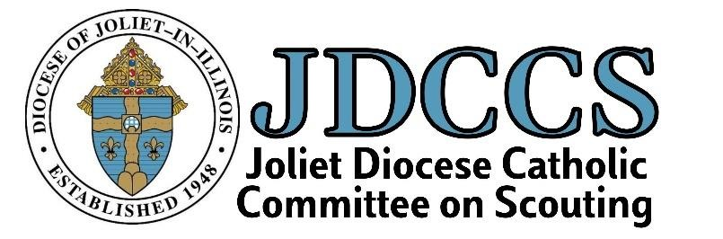

ANNUAL DAY OF RECOLLECTION SCOUT RETREAT
NAVIGATE OUR FAITH: THE EUCHARISTIC REVIVAL
What | The Annual Winter JDCCS Scout Retreat is a retreat for the benefit of ALL Catholic Scouts, grades 2-12. Grades 2-5 MUST be accompanied by an adult. Since this retreat focuses on the Eucharist, it is recommended that all participants have received their first Eucharist.  - Please wear the appropriate uniform for your organization. Please arrive 15 minutes early and meet in the narthex before mass.  - Please bring a water bottle, pencil/pen and notebook
Who | Scouts in the following Organizations (and Their Adult Leaders and/or Parents/Guardians) are welcome: Catholic American Heritage Girls, Brownies, Camp Fire Youth, Cub Scouts, Girl Scouts, Scouts BSA, and Venturers and members of other Catholic youth scouting programs. Grades grades 2-5 must be accompanied by an adult.
What to Know | Your day will consist of prayer, reflection, presentations, and some scouting fun. If you are working on a Catholic religious medal and are required to attend a retreat, this event would fulfill that requirement.
Cost | $5 per person
Totem | If you attended the retreats in the past, bring your totem with you for this year’s beads.
Boards of Review | Personnel will be available for Ad Altare Dei and Pope Pius XII Boards of review after the retreat PROVIDED the request is made on the family registration form (due by February 10, 2024). Be sure to bring your completed emblem book.
RSVP | RSVP for all attendees is REQUIRED – Each family must submit a registration form and a permission form for each youth, and an adult waiver and medical form for each adult. Registration and permissions slips must be received by February 10, 2022. All forms can be found on the JDCCS website Day of Recollection page.
Contact Person | Karen Zeller (630) 696-2904 or email krnzllr@gmail.com.
Saturday, February 17, 2024 8 am – 12 pm
St. Michael’s Catholic Church 310 S. Wheaton Ave. Wheaton, IL

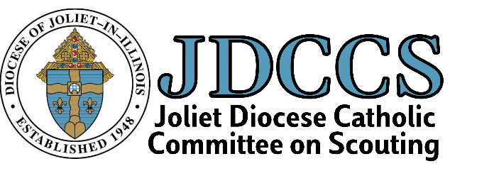
2024 Winter Day of Recollection
Family Registration Form
Complete and Mail in or electronically submit with Diocesan Forms
Reminder! All children in grades 2-5 must be accompanied by an adult!
Family Last Name(s) | First  Name(s) of  Participants | Child’s  Grade*  *2 – 5 must  attend with adult | Child  Age | “A” for adult | Email Address  For each adult and child.  Adding a child’s email is giving parental permission to email your child. YPT rules MUST be followed.  (A confirmation email will be sent to adults) | Organization & Unit #  BSA, Girl Scouts,  AHG,  Campfire, etc. | Add’tl Forms submitted w/this form? (see website Day of Recollection for links)  YES/NO  (Youth-Permission (1)  Adult-waiver and permission (2 forms) | Fee  $5 /person registering by mail  $6/person if registering by email & paying by Paypal @JDCCS
 |  |  |  |  |  |  |  | TOTAL $
Home Address :_____________________________________ Best Phone Number: _______________________Email:______________________________ Parish Name :_________________________________________ Parish City: ____________________________________
BOARD OF REVIEW REQUEST
I would like to request a board of review AFTER THE RETREAT for (scout name/s)__________________________________________________ for (circle one):
AD ALTARE DEI POPE PIUS XII OTHER
MAIL IN: Submit Family Registration Form, Adult Waiver Form, Youth Permission Slips, and a check made payable to JDCCS to: Karen Zeller, 324 E. Franklin St., Wheaton, IL 60187 SUBMIT ONLINE: Send Scan of this form to krnzllr@gmail.com. We will invoice you for Paypal payment. Register Early! Forms must be received by February 10, 2024!

